SafeZone National and Local Resource Guide

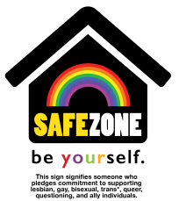
This sign identifies someone who has been trained and who pledges commitment to supporting lesbian, gay, bisexual, trans*, queer, questioning and ally individuals.

The Trevor Project is an excellent online resource for LGBTQ and allies. It has a 24/7 phone, text, and chat lines, and all kinds of other resources. The website is: www.thetrevorproject.org

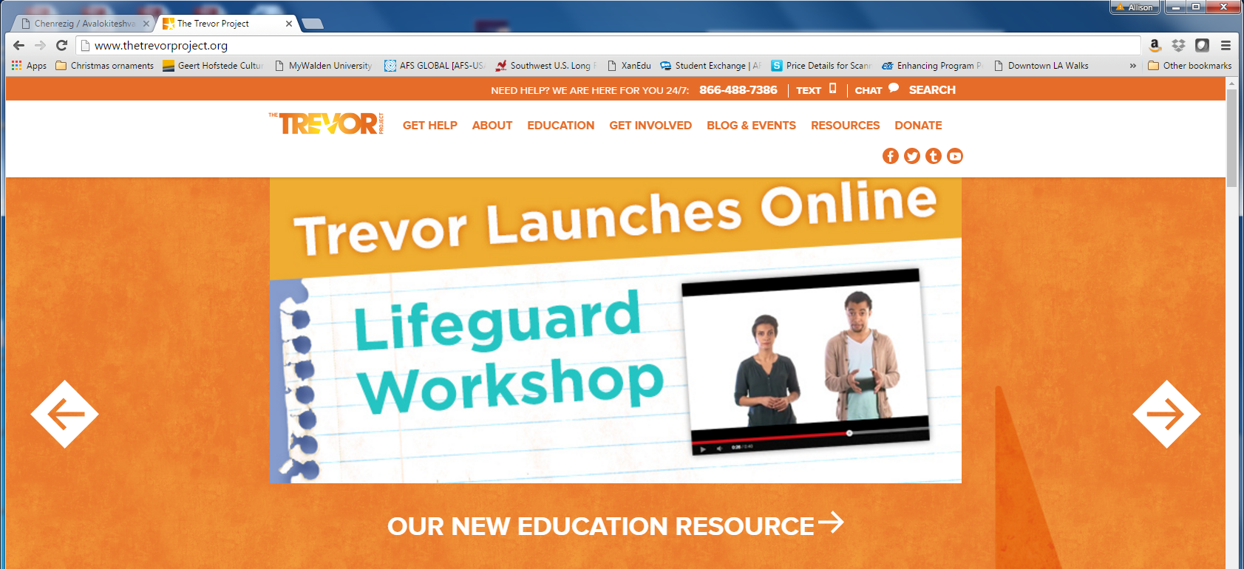

The Moorpark College Student Health Center is an important on-campus resource. It offers 6 free sessions of psychological counseling as well as a myriad of medical services through our physician, nurse practitioner, and registered nurses.
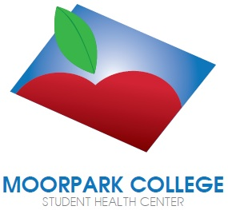

MC Student Health Center
Administration Building, Room 111
Phone: 805-378-1413
www.moorparkcollege.edu/health

Use the MC Student Health Center website students to access mental health, substance abuse, and eating disorder screening.

The MC Office of Title IX (Sexual Misconduct) page on the MC website is a great place to go to learn about laws and policies pertaining to sexual misconduct. It describes the broad spectrum of behaviors included in the definition, explains the rights of victims and the accused, and gives information on victims’ options. http://www.moorparkcollege.edu/departments/student-services/title-ix-sexual-misconduct

Other Important Resources

Suicide Hotline: 1-800-273-TALK or go to www.suicidepreventionlifeline.org
Mental Health Crisis: 911 or 866-998-2243 Medical Emergency: 911 Campus Police: 805-378-1455
Abuse/Rape/Domestic Violence: 805-656-1111 Alcohol/Drug Services: 805-577-1724
Information and Referral Services for Ventura County: Dial 211 or go to http://www.211ventura.org/

